Практическая работа №21  
Работа с MacroRecorder’ом

-----------------------------------------------------------------------------------------------------------------------------------------------------------------

Задание №1

Условие:

Создайте макрос с именем “Шаблон”, который бы работал в пределах данной рабочей книги. Назначьте данному макросу комбинацию функциональных клавиш Ctrl + q. Макрос должен содержать последовательность действий 1 – 5

Исходный код:

Sub Шаблон()  
'  
' Шаблон Макрос  
'  
  
'  
 Range("A3").Select  
 ActiveCell.FormulaR1C1 = "Район"  
 Range("B3").Select  
 ActiveCell.FormulaR1C1 = "Интервал глубин, м"  
 Range("C3").Select  
 ActiveCell.FormulaR1C1 = "М-1"  
 Range("A1").Select  
   
 Range("A1:D1").Select  
 With Selection  
 .HorizontalAlignment = xlCenter  
 .VerticalAlignment = xlBottom  
 .WrapText = False  
 .Orientation = 0  
 .AddIndent = False  
 .ShrinkToFit = False  
 .MergeCells = False  
 End With  
 Selection.Merge  
 Range("A2:D2").Select  
 Range("D2").Activate  
 With Selection  
 .HorizontalAlignment = xlCenter  
 .VerticalAlignment = xlBottom  
 .WrapText = False  
 .Orientation = 0  
 .AddIndent = False  
 .ShrinkToFit = False  
 .MergeCells = False  
 End With  
 Selection.Merge  
 Range("A3:C8").Select  
 Selection.Borders(xlDiagonalDown).LineStyle = xlNone  
 Selection.Borders(xlDiagonalUp).LineStyle = xlNone  
 With Selection.Borders(xlEdgeLeft)  
 .LineStyle = xlContinuous  
 .Weight = xlThin  
 .ColorIndex = xlAutomatic  
 End With  
 With Selection.Borders(xlEdgeTop)  
 .LineStyle = xlContinuous  
 .Weight = xlThin  
 .ColorIndex = xlAutomatic  
 End With  
 With Selection.Borders(xlEdgeBottom)  
 .LineStyle = xlContinuous  
 .Weight = xlThin  
 .ColorIndex = xlAutomatic  
 End With  
 With Selection.Borders(xlEdgeRight)  
 .LineStyle = xlContinuous  
 .Weight = xlThin  
 .ColorIndex = xlAutomatic  
 End With  
 With Selection.Borders(xlInsideVertical)  
 .LineStyle = xlContinuous  
 .Weight = xlThin  
 .ColorIndex = xlAutomatic  
 End With  
 With Selection.Borders(xlInsideHorizontal)  
 .LineStyle = xlContinuous  
 .Weight = xlThin  
 .ColorIndex = xlAutomatic  
 End With  
 With Selection.Font  
 .Name = "Calibri"  
 .Size = 14  
 .Strikethrough = False  
 .Superscript = False  
 .Subscript = False  
 .OutlineFont = False  
 .Shadow = False  
 .Underline = xlUnderlineStyleNone  
 .ThemeColor = xlThemeColorLight1  
 .TintAndShade = 0  
 .ThemeFont = xlThemeFontMinor  
 End With  
 With Selection.Font  
 .Name = "Times New Roman"  
 .Size = 14  
 .Strikethrough = False  
 .Superscript = False  
 .Subscript = False  
 .OutlineFont = False  
 .Shadow = False  
 .Underline = xlUnderlineStyleNone  
 .ThemeColor = xlThemeColorLight1  
 .TintAndShade = 0  
 .ThemeFont = xlThemeFontNone  
 End With  
 Range("A1:D2").Select  
 With Selection.Font  
 .Name = "Times New Roman"  
 .Size = 12  
 .Strikethrough = False  
 .Superscript = False  
 .Subscript = False  
 .OutlineFont = False  
 .Shadow = False  
 .Underline = xlUnderlineStyleNone  
 .ThemeColor = xlThemeColorLight1  
 .TintAndShade = 0  
 .ThemeFont = xlThemeFontNone  
 End With  
 With Selection.Font  
 .Name = "Times New Roman"  
 .Size = 14  
 .Strikethrough = False  
 .Superscript = False  
 .Subscript = False  
 .OutlineFont = False  
 .Shadow = False  
 .Underline = xlUnderlineStyleNone  
 .ThemeColor = xlThemeColorLight1  
 .TintAndShade = 0  
 .ThemeFont = xlThemeFontNone  
 End With  
 Selection.Font.Bold = True  
 Range("A1:D1").Select  
 With Selection  
 .HorizontalAlignment = xlGeneral  
 .VerticalAlignment = xlBottom  
 .WrapText = False  
 .Orientation = 0  
 .AddIndent = False  
 .ShrinkToFit = False  
 .MergeCells = True  
 End With  
 Selection.Merge True  
 Range("A2:D2").Select  
 With Selection  
 .HorizontalAlignment = xlGeneral  
 .VerticalAlignment = xlBottom  
 .WrapText = False  
 .Orientation = 0  
 .AddIndent = False  
 .ShrinkToFit = False  
 .MergeCells = True  
 End With  
 Selection.Merge True  
 Range("A1:C2").Select  
 Range("C2").Activate  
 With Selection  
 .HorizontalAlignment = xlCenter  
 .VerticalAlignment = xlBottom  
 .WrapText = False  
 .Orientation = 0  
 .AddIndent = False  
 .ShrinkToFit = False  
 .MergeCells = False  
 End With  
 Range("A1:C2").Select  
 With Selection  
 .HorizontalAlignment = xlCenter  
 .VerticalAlignment = xlBottom  
 .WrapText = False  
 .Orientation = 0  
 .AddIndent = False  
 .ShrinkToFit = False  
 .MergeCells = False  
 End With  
 Selection.Merge  
 With Selection  
 .HorizontalAlignment = xlGeneral  
 .VerticalAlignment = xlBottom  
 .WrapText = False  
 .Orientation = 0  
 .AddIndent = False  
 .ShrinkToFit = False  
 .MergeCells = True  
 End With  
 Selection.Merge True  
 Range("A1:C1").Select  
 Range("C1").Activate  
 With Selection  
 .HorizontalAlignment = xlCenter  
 .VerticalAlignment = xlBottom  
 .WrapText = False  
 .Orientation = 0  
 .AddIndent = False  
 .ShrinkToFit = False  
 .MergeCells = False  
 End With  
 Selection.Merge  
 Range("A1").Select  
 ActiveCell.FormulaR1C1 = "Значения показателя вертикального ослабления"  
 Range("A2").Select  
 ActiveCell.FormulaR1C1 = "для открытых океанских районов"  
 Range("A2:C2").Select  
 Range("C2").Activate  
 With Selection  
 .HorizontalAlignment = xlCenter  
 .VerticalAlignment = xlBottom  
 .WrapText = False  
 .Orientation = 0  
 .AddIndent = False  
 .ShrinkToFit = False  
 .MergeCells = False  
 End With  
 Selection.Merge  
 Range("G5").Select  
End Sub  
  
Sub Цвета()  
'  
' Цвета Макрос  
'  
  
'  
 Range("A3:A8").Select  
 ExecuteExcel4Macro "PATTERNS(1,0,5,TRUE,2,4,0,0.599993896298105)"  
 Range("B3:B8").Select  
 ExecuteExcel4Macro "PATTERNS(1,0,12611584,TRUE,2,3,0,0)"  
 Range("C3:C8").Select  
 ExecuteExcel4Macro "PATTERNS(1,0,15773696,TRUE,2,3,0,0)"  
 Range("D1").Select  
End Sub

Скриншоты программы:

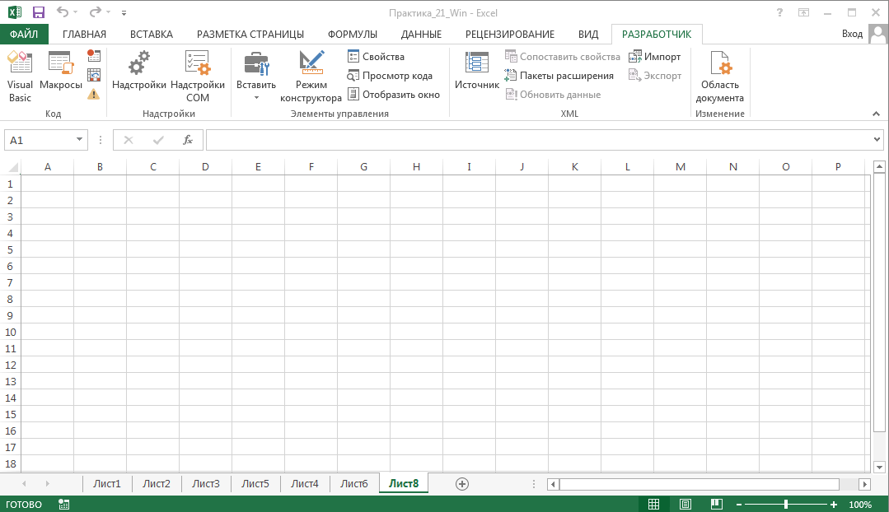

а) До применения макроса ‘Шаблон’

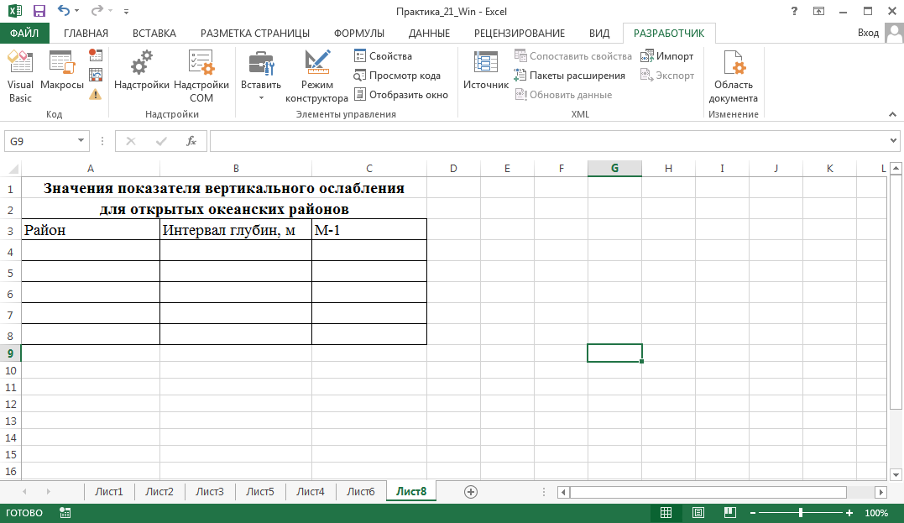

б) После применения макроса “Шаблон”

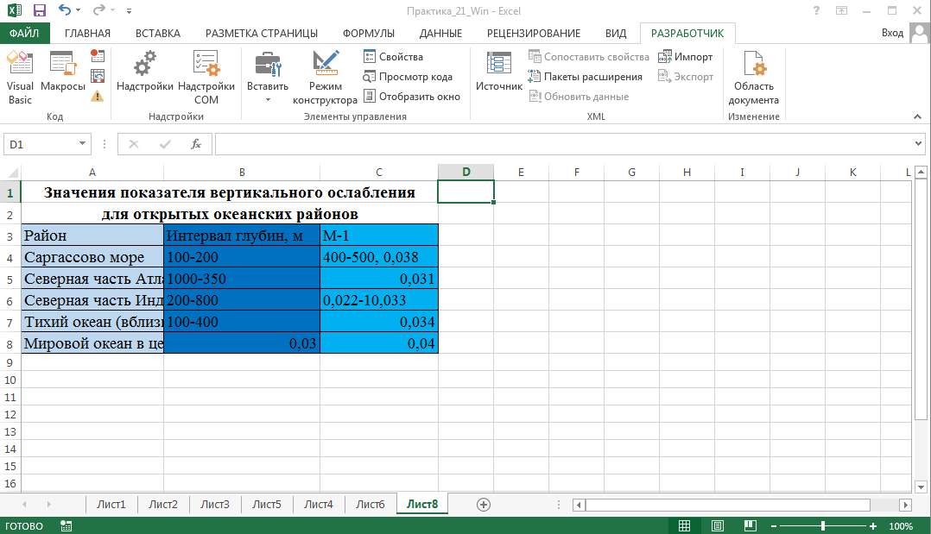

в) После применения макроса “Цвета”

-----------------------------------------------------------------------------------------------------------------------------------------------------------------

Задание №2

Условие:

Дан список из 15 записей, содержащий информацию о книгах: название, автор, количество экземпляров.

Написать макрос, который:

А) Раскрашивает таблицу в разные цвета;

Б) Строит диаграмму, в которой отражается информация об авторах и количестве экземпляров его книг.

Исходный код:

Sub Задание2()  
'  
' Задание2 Макрос  
'  
  
'  
 Range("A1").Select  
 ExecuteExcel4Macro "PATTERNS(1,0,5,TRUE,2,4,0,0.799981688894314)"  
 Range("B1").Select  
 ExecuteExcel4Macro "PATTERNS(1,0,5,TRUE,2,4,0,0.799981688894314)"  
 Range("C1").Select  
 ExecuteExcel4Macro "PATTERNS(1,0,5,TRUE,2,4,0,0.799981688894314)"  
 Range("A2").Select  
 ExecuteExcel4Macro "PATTERNS(1,0,5,TRUE,2,4,0,0.599993896298105)"  
 Range("B2").Select  
 ExecuteExcel4Macro "PATTERNS(1,0,5,TRUE,2,4,0,0.599993896298105)"  
 Range("C2").Select  
 ExecuteExcel4Macro "PATTERNS(1,0,5,TRUE,2,4,0,0.599993896298105)"  
 Range("A3").Select  
 ExecuteExcel4Macro "PATTERNS(1,0,5,TRUE,2,4,0,0.399975585192419)"  
 Range("B3").Select  
 ExecuteExcel4Macro "PATTERNS(1,0,5,TRUE,2,4,0,0.399975585192419)"  
 Range("C3").Select  
 ExecuteExcel4Macro "PATTERNS(1,0,5,TRUE,2,4,0,0.399975585192419)"  
 Range("A4").Select  
 ExecuteExcel4Macro "PATTERNS(1,0,5,TRUE,2,4,0,-0.249977111117893)"  
 Range("B4").Select  
 ExecuteExcel4Macro "PATTERNS(1,0,5,TRUE,2,4,0,-0.249977111117893)"  
 Range("C4").Select  
 ExecuteExcel4Macro "PATTERNS(1,0,5,TRUE,2,4,0,-0.249977111117893)"  
 Range("A5").Select  
 ExecuteExcel4Macro "PATTERNS(1,0,5,TRUE,2,4,0,-0.249977111117893)"  
 Range("B5").Select  
 ExecuteExcel4Macro "PATTERNS(1,0,5,TRUE,2,4,0,-0.249977111117893)"  
 Range("C5").Select  
 ExecuteExcel4Macro "PATTERNS(1,0,5,TRUE,2,4,0,-0.249977111117893)"  
 Range("A6").Select  
 ExecuteExcel4Macro "PATTERNS(1,0,5,TRUE,2,4,0,0.399975585192419)"  
 Range("B6").Select  
 ExecuteExcel4Macro "PATTERNS(1,0,5,TRUE,2,4,0,0.399975585192419)"  
 Range("C6").Select  
 ExecuteExcel4Macro "PATTERNS(1,0,5,TRUE,2,4,0,0.399975585192419)"  
 Range("A7").Select  
 ExecuteExcel4Macro "PATTERNS(1,0,5,TRUE,2,4,0,0.599993896298105)"  
 Range("B7").Select  
 ExecuteExcel4Macro "PATTERNS(1,0,5,TRUE,2,4,0,0.599993896298105)"  
 Range("C7").Select  
 ExecuteExcel4Macro "PATTERNS(1,0,5,TRUE,2,4,0,0.599993896298105)"  
 Range("C8").Select  
 ExecuteExcel4Macro "PATTERNS(1,0,5,TRUE,2,4,0,0.799981688894314)"  
 Range("B8").Select  
 ExecuteExcel4Macro "PATTERNS(1,0,5,TRUE,2,4,0,0.799981688894314)"  
 Range("A8").Select  
 ExecuteExcel4Macro "PATTERNS(1,0,5,TRUE,2,4,0,0.799981688894314)"  
 Range("A9").Select  
 ExecuteExcel4Macro "PATTERNS(1,0,5,TRUE,2,4,0,0.799981688894314)"  
 Range("B9").Select  
 ExecuteExcel4Macro "PATTERNS(1,0,5,TRUE,2,4,0,0.799981688894314)"  
 Range("C9").Select  
 ExecuteExcel4Macro "PATTERNS(1,0,5,TRUE,2,4,0,0.799981688894314)"  
 Range("C10").Select  
 ExecuteExcel4Macro "PATTERNS(1,0,5,TRUE,2,4,0,0.599993896298105)"  
 Range("B10").Select  
 ExecuteExcel4Macro "PATTERNS(1,0,5,TRUE,2,4,0,0.599993896298105)"  
 Range("A10").Select  
 ExecuteExcel4Macro "PATTERNS(1,0,5,TRUE,2,4,0,0.599993896298105)"  
 Range("A11").Select  
 ExecuteExcel4Macro "PATTERNS(1,0,5,TRUE,2,4,0,0.399975585192419)"  
 Range("B11").Select  
 ExecuteExcel4Macro "PATTERNS(1,0,5,TRUE,2,4,0,0.399975585192419)"  
 Range("C11").Select  
 ExecuteExcel4Macro "PATTERNS(1,0,5,TRUE,2,4,0,0.399975585192419)"  
 Range("C12").Select  
 ExecuteExcel4Macro "PATTERNS(1,0,5,TRUE,2,4,0,-0.249977111117893)"  
 Range("B12").Select  
 ExecuteExcel4Macro "PATTERNS(1,0,5,TRUE,2,4,0,-0.249977111117893)"  
 Range("A12").Select  
 ExecuteExcel4Macro "PATTERNS(1,0,5,TRUE,2,4,0,-0.249977111117893)"  
 Range("A13").Select  
 ExecuteExcel4Macro "PATTERNS(1,0,5,TRUE,2,4,0,-0.249977111117893)"  
 Range("B13").Select  
 ExecuteExcel4Macro "PATTERNS(1,0,5,TRUE,2,4,0,-0.249977111117893)"  
 Range("C13").Select  
 ExecuteExcel4Macro "PATTERNS(1,0,5,TRUE,2,4,0,-0.249977111117893)"  
 Range("C14").Select  
 ExecuteExcel4Macro "PATTERNS(1,0,5,TRUE,2,4,0,0.399975585192419)"  
 Range("B14").Select  
 ExecuteExcel4Macro "PATTERNS(1,0,5,TRUE,2,4,0,0.399975585192419)"  
 Range("A14").Select  
 ExecuteExcel4Macro "PATTERNS(1,0,5,TRUE,2,4,0,0.399975585192419)"  
 Range("A15").Select  
 ExecuteExcel4Macro "PATTERNS(1,0,5,TRUE,2,4,0,0.599993896298105)"  
 Range("B15").Select  
 ExecuteExcel4Macro "PATTERNS(1,0,5,TRUE,2,4,0,0.599993896298105)"  
 Range("C15").Select  
 ExecuteExcel4Macro "PATTERNS(1,0,5,TRUE,2,4,0,0.599993896298105)"  
 Range("C16").Select  
 ExecuteExcel4Macro "PATTERNS(1,0,5,TRUE,2,4,0,0.599993896298105)"  
 Range("C16").Select  
 ExecuteExcel4Macro "PATTERNS(1,0,5,TRUE,2,4,0,0.799981688894314)"  
 Range("B16").Select  
 ExecuteExcel4Macro "PATTERNS(1,0,5,TRUE,2,4,0,0.799981688894314)"  
 Range("A16").Select  
 ExecuteExcel4Macro "PATTERNS(1,0,5,TRUE,2,4,0,0.799981688894314)"  
 Range("A17").Select  
 ExecuteExcel4Macro "PATTERNS(1,0,5,TRUE,2,4,0,0.599993896298105)"  
 Range("B17").Select  
 ExecuteExcel4Macro "PATTERNS(1,0,5,TRUE,2,4,0,0.599993896298105)"  
 Range("C17").Select  
 ExecuteExcel4Macro "PATTERNS(1,0,5,TRUE,2,4,0,0.599993896298105)"  
 Range("F3").Select  
 Range("B1:C17").Select  
 ActiveSheet.Shapes.AddChart2(216, xlBarClustered).Select  
 ActiveChart.SetSourceData Source:=Range("Лист6!$B$1:$C$17")  
 Range("D19").Select  
End Sub

Скриншоты программы: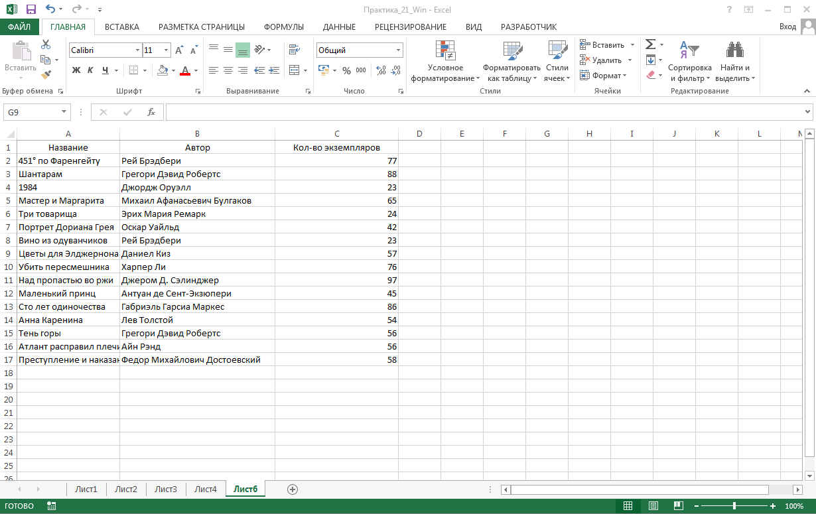

а) До применения макроса “Задание2”

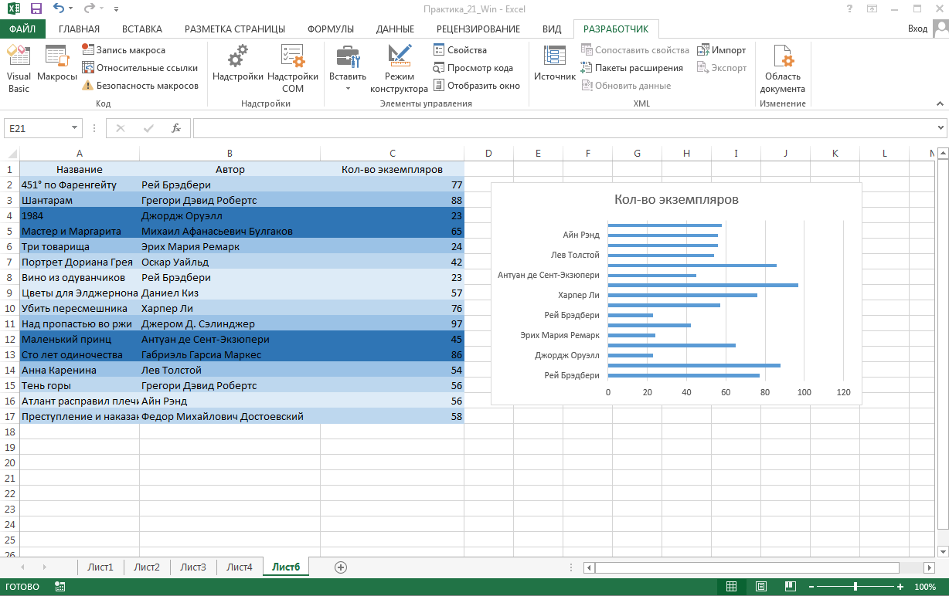

б) После применения макроса “Задание2”

Задание №3

Условие:

Написать в Word’е макрос, который бы шифровал текст следующим образом: каждая буква заменялась бы следующей по алфавиту.

Исходный код: